**PHP Notes**

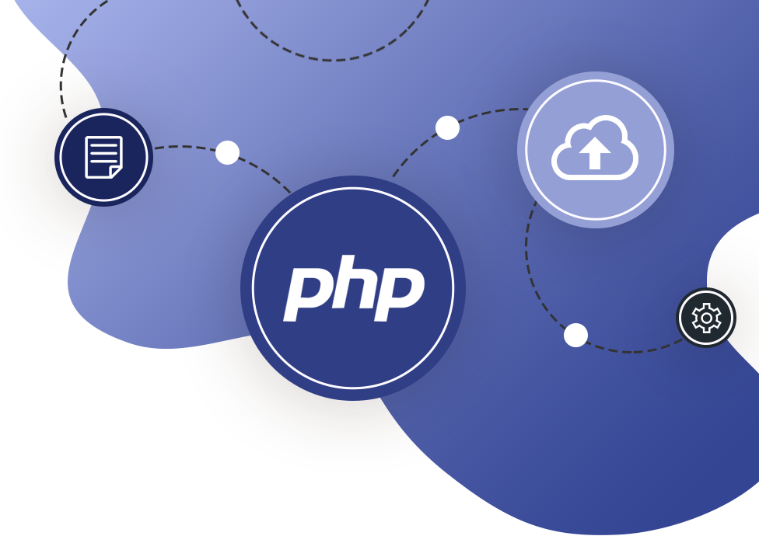

**Week 1 Intro to PHP**

*PHP: Hypertext Preprocessor*

**What:**

* PHP is a popular general-purpose scripting language that is especially suited to web development.
* PHP is a scripting language vice compiled language (interpreted language).
* PHP is a server-side technology
  + Other SS alternatives
    - ASP .net
    - Ruby
    - NodeJs
* PHP is cross platform.227infose

**Why:**

* PHP can interact with databases
* PHP enables dynamic web applications
* PHP is free and cross-platform
* 6th most popular programming language
* 80% of sites use it.

**How It works:**

* PHP is on the server.
* PHP can create HTML on demand
* PHP Module is added to the server to increase PHP functionality

Development Environment:

[www.mamp.info](http://www.mamp.info)

Requires PHP to be placed in Documents folder.

[www.apachefriends.org](http://www.apachefriends.org)

[www.wampserver.com](http://www.wampserver.com)

Resources:

PHP Manual

https://www.php.net/manual/en/index.php

PHP modules:

phpinfo();